A DETAILED LESSON PLAN IN SCIENCE
Strategy: Inductive Method and Collaborative

- OBJECTIVES

At the end of the lesson the students should be able to:

- define pollination
- identify the various type of pollination.
- describe how pollination occurs.
- participate actively in the discussion and class activity.

- SUBJECT MATTER

- TOPIC: Plant Reproduction
- SUBTOPIC: Pollination
- MATERIALS: Powerpoint presentation, video, pictures
- REFERENCES: Science for Grade IX

- PROCEDURE

Teacher’s Activity | Student’s Activity
- Daily Routine  - Prayer  Stand up everyone.  Kindly lead the prayer, Muhammad Akbar.  - Greetings  Good morning class!  - Keeping the class in order  Before you take your seats.  Kindly pick up those pieces of  trash under your chair and arrange your seat properly.  Are you done?  Okay, sit down.  - Attendance  Is there any absent?  Very good, perfect attendance.  - Review  Do you remember our topic last week?  So last week we tackled about the human reproduction of male and female. Can you give one part of the male reproductive system and explain its function? Yes, Muhammad Nabil Ulya.  Very good. So how about you, Farsya Salsabila Adriyanti.  Very good. How about the Female reproductive system? Yes, Prayoga Pengestoe.  Another one, Yes Muhammad Rommy.  Very good. Seems you understand our topic last week.  Since you already understand the past lesson we can now easily move on to our next topic.  - Motivation  But class before we proceed to our next topic. I prepare an activity it’s called Word Hunt. What you are going to do is to find the words in the box.  (the teacher will present the different words that the students are going to find)  (after 8 minutes)  - Lesson Proper  Class our topic for today is about pollination. Any idea about pollination? Yes, Luthfi Nor Anshori.  Very good, pollination is a plant process. It’s the vital first step that leads to seed formation and food production. It is the act of transferring pollen grains from the male anther of a flower to the female stigma. We all know, plants cannot move, so they rely on wind or water, or animals (mainly insects) that we call pollinators, to transfer pollen from the male parts of flowers to the female parts of flowers. Pollen grains are the male genetic material of a plant, and pollination is all about how pollen is transferred to the female part of flowers.  Can you name an animal/insects involved in pollination? Yes, Delfian Nur Abdil.  Very good. Another one, Yes Aira Khanza Zahra  How about you, Nadia.  Very well said. All of you are correct. Bees, birds like hummingbird and many more are serve as pollinators.  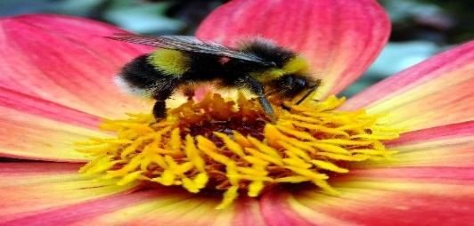  Okay class, look at the picture. What do you see?  Very good. Why do you think that bees or other animals comes to flowers? Any idea, yes Shafa Aziza.  Very good. One reason is because they attractive to color and also all pollinators, both insects and vertebrates, visit flowers to get something out of them for themselves.  What are bees taken from flowers? Any idea, yes Muhammad Akbar.  Very good. This may be nectar, pollen or both. Bees or other bee-like, insects have special structures on their bodies in which they store the pollen they have collected. Like for example the Bumble bees have baskets on the hind legs, to which they regularly transfer the pollen that has landed on their bodies. The pollen in these baskets is not available for pollination any more. For pollination purposes only the loose pollen on their bodies’ matters that accidentally landed in the stigma. That’s why there is a mutually beneficial relationship between bees or other animals with flowers. Bees and other animals with flowers can actually help the flowers to pollinate.  Do you have any questions about pollination?  Okay, we are done discussing about what is pollination and now let’s discuss about the type of intermediaries/pollinators.  a). anemogami  Have you ever observed of corn or rice?  What did you notice about their flowers?  Very well said.  Corn and rice plants have flowers that are small and easy flower stalks sway when the wind. Plants with flowers that are small, the amount of interest a lot and lightweight, and do not produce nectar or odors are some traits of plants pollinated by wind.  (the teacher will show the different example of plants that are wind pollinated)  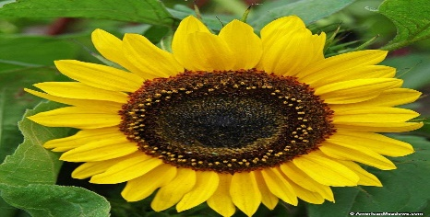  b). entomogami  What did you notice in this sunflower? Yes Gusti Aliya Zafira.  Very good, Sunflower has an attractive and bright colors of yellow, and produce nectar.  Do you know what the function of these traits for sunflower?  Very well said. Feature owned sunflowers and which have a similar very attractive to insects, such as bees, to perch and suck nectar. Generally, the pollen produced by flowers are sticky so easily attached to the legs of insects. Thus, the insects took to move pollen to the pistil.  c). ornitogami  What do you think about the meaning of ornitogami? Any idea, yes Devie Widi Herlianto.  Very good. Can you give an example of bird? Yes, Nathanael Simamora  Very good. Another one, Yunita.  Plants that make use of pollination by birds commonly have large flower size bright red, orange or yellow flowers and very little scent.  d). kiropterogami  What do you think is the difference between bat pollination to other type of pollinators? Yes, Muhammad Falah.  Very good, usually happen at night, they are attractive to bright color and produces rich smell. Bats are important pollinators in warm climates – primarily desert and tropical climates such as the Pacific Islands, Southeast Asia and Africa. They are critical pollinators for plants of the American Southwest, including agave plants, Saguaro and organ pipe cactus.  e). antropogami  How antropogami done?  It is done usually when the flowers are married two, meaning in one tree there are only male flowers or female flowers only. Antropogami also be done if the pollen of a plant difficult to meet with the pistil, so it is difficult to perform self-pollinating.  (the teacher will post the example of plant which are antropogami)  Any questions or clarifications regarding the types of pollinators?  In the process of pollination, pollen can be derived from the flower itself or from any other interest that is still within a species. Based on the origin of pollen, it can be divided into several kinds.  The first one is the self-pollination, the second one is the pollination neighbor and the third one is the cross-pollination and the last one is the pollinated hybrid.  The first type is self-pollination. What do you mean about self-pollination? Any idea, yes Daud Manurung.  Very good. It is a type of pollination wherein the transferring of the pollen's from anther to stigma is come from in the same flower.  (the teacher will post the different example of self-pollinating plants)  The second one is the pollination neighbors. Any idea about this? Yes, Rahman Safi’l.  Thank you. It is happen when the pollen that sticks to the stigma comes from another flower on the same plant.  (the teacher will post the different example of pollinating neighbors)  The third one is the cross-pollination. How about this, any idea? Yes, Angelina Aryani Jandu.  Very good. It is happen when one plant pollinates a plant of another variety. The two plants' genetic material combines and the resulting seeds from that pollination will have characteristics of both varieties and is a new variety. Sometimes cross pollinating is used intentionally in the garden to create new varieties.  (The teacher will post the different picture of cross-pollinating).  Did you understand class?  Any questions and clarification?  - Evaluation  We’re done discussing about pollination, type of pollinators and pollination. I want you to do is to investigate how pollinate flowers.  What do you need to bring?  You need to bring ball pen and paper. I will group you into 11, which means that you have a 3 members. Walk around the school environment like garden and write of some interest that you meet and record the result of your observation in this table.  (the teacher will give the table)  I will give you only 15 minutes to observe outside. And after that I will call some students to present their observation. . Is that clear?  Any question about the activity?  Ok. You may go.  (after 15 minutes)  (the teacher will call some students to present their observation)  - Assignment  In a whole piece of paper answer about the following :  - Discuss the importance of pollination?  - Explain the role of pollination in plants?  Done copying?  Kindly read the assignment.  Yes, Muhammad Wahyu Firdaus.  Is the assignment clear to you?  Okay. That’s all for today.  Goodbye class! | 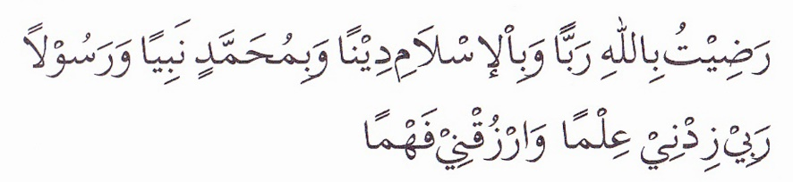  Good morning Sir!  Yes Sir.  None Sir.  Yes, Sir.  Penis, wherein the functions as both reproductive organ and a urinary channel.  Testis which produces sperms by meiosis.  Ovaries, it produce eggs and sex hormones.  Vagina sir, wherein it receives spermatozoa from outside and lets a baby pass through at birth.  Okay, Sir.  (the student will search for the word)  Pollination is the transfer of pollen from a male part of a plant to a female part of a plant  Bees, Sir.  Birds.  Bat, Sir  It’s a flower and bees.  I think sir because they are attractive to colors.  .  Honey, sir.  None, sir.  Yes  It is small.  Yellow in color.  I think sir the function of these traits are to attract the insect since insects are very attractive to bright colors.  Pollination about bird sir.  Sunbird.  honeycreppers  I think sir bat pollination happen usually at night.  None, Sir.  I think sir when we say self-pollination it comes from the flower itself.  Pollination neighbor come from neighbor flower with the same plant.  I think cross-pollination come from another flower but with different plants.  Yes, sir.  None, sir.  Yes, sir.  None, sir.  (the student will copy their assignment)  Yes, Sir.  In a whole piece of paper answer about the following :  - Discuss the importance of pollination?  - Explain the role of pollination in plants?  Yes, sir.  Goodbye, sir.

